Sapwood estimates applied only to PSME - up to 65 years.

Outside date classes:
Best – Bark, non-eroded beetle galleries, or other signs of being very near (within ~5 year) a true mortality date.

Good – Sapwood obviously present in the case of PSME and PIED. For PIED some were added to this class without sapwood, where the exterior surface showed light to little erosion. With sapwood estimate in PSME could be very close (within ~10 years) to terminal date. PIED will have a grater range, but some samples could be very close (within ~10 years).

Fair – No sapwood, but condition of exterior surface showing only modest erosion of heartwood. Most likely near heart/sap boundary. Estimated within ~100 years of terminal date.

Poor – Obviously highly eroded – no clue how close these are to a terminal date.

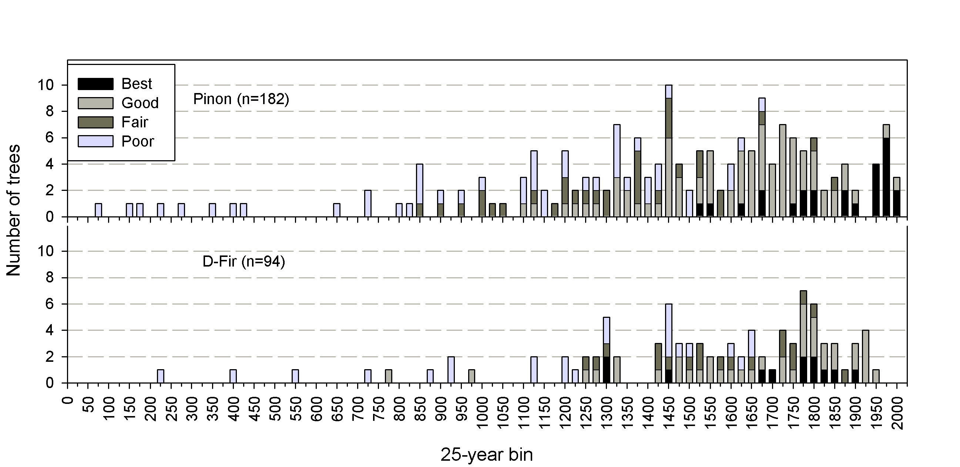
All outside dates.

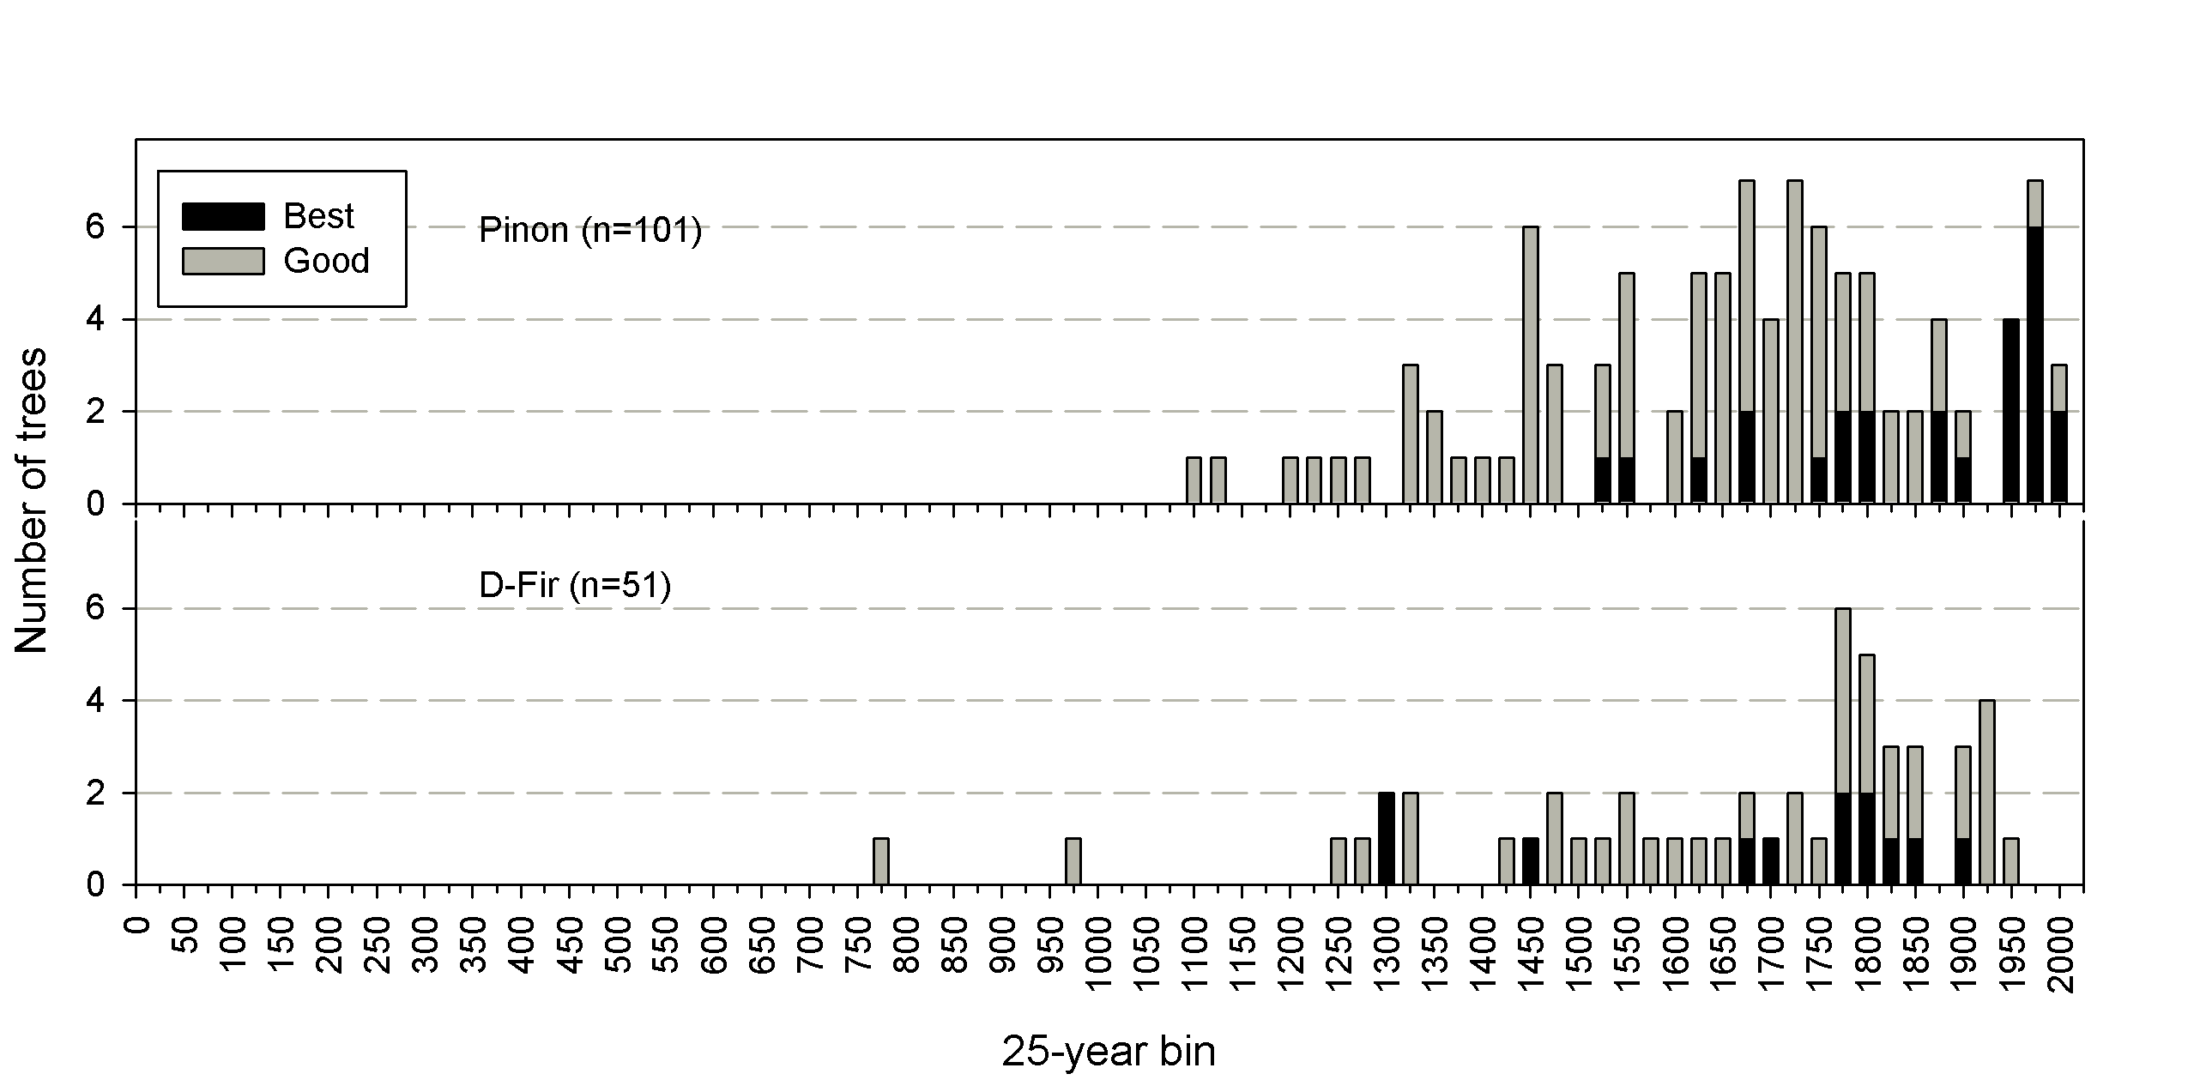
Higher quality dates - 25 yr bin.

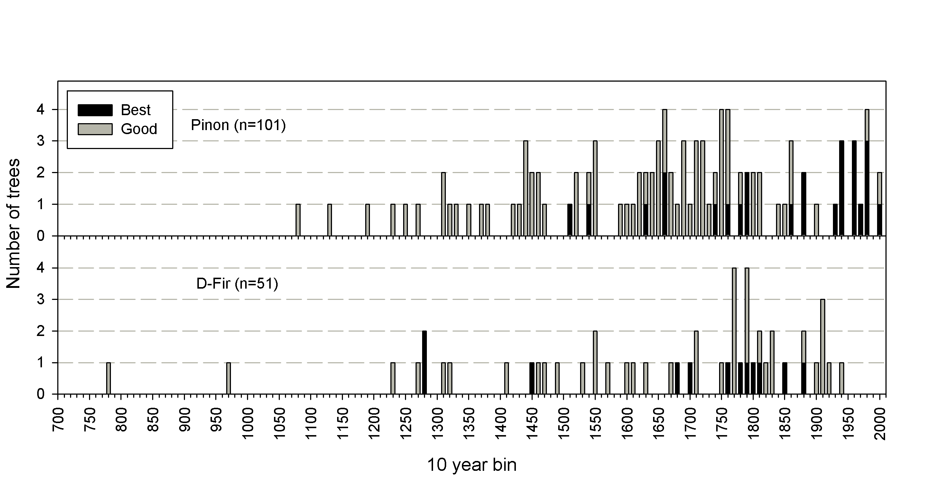
Higher quality dates – 10 yr bin.

