Sensitivity of Semi-Arid Southwestern Forests to Climate-Induced Disturbances:

Fire History of the Santa Fe Municipal Watershed

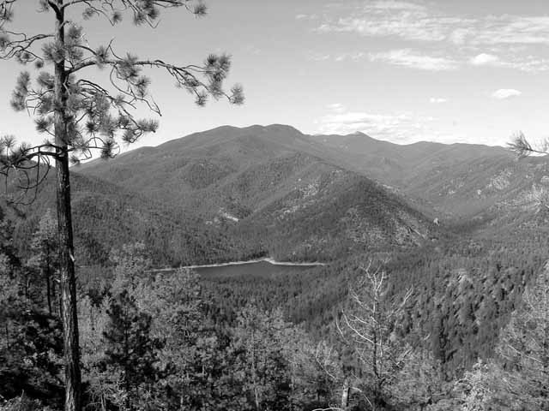

Submitted by:

Jeff Balmat
Research Assistant
Laboratory of Tree-Ring Research
University of Arizona
Tucson, AZ 85721

20 December 2004

Sensitivity of Semi-Arid Southwestern Forests to Climate-Induced Disturbances:
Fire History of the Santa Fe Municipal Watershed

Jeff Balmat

Introduction
Wildfire has assumed a prominent position in land management policy and operations over the past several decades. Recent fires of significant size and economic consequence (e.g., the 2000 Cerro Grande fire at Los Alamos) have given a sharp edge to accumulating ecological research documenting historical fire patterns and human-initiated fire regime change. Wildfire is understood to be a keystone landscape process in most upland and montane forests of the American Southwest (Allen 2002). Over the past century or more in most of this region land use practices have augmented the human dimension of fire occurrence, typically a climate-driven process (Swetnam and Betancourt 1990). Many fire histories reconstructed from dendrochronological evidence show a marked decline or total cessation of fire in the mid 1800s to early 1900s (Swetnam and Baisan 1996), corresponding to the initiation of intensive livestock grazing and fire exclusion policies (Covington and Moore 1994). Responses in forest structure and composition to altered fire regimes feed back to promote a heightened severity in the fires that do occur. Fire regimes, vegetation patterns and the interactions between the two are expected to be made more complex by shifts in regional climate.
All southwestern forests are subject to climatic variability and nearly all have felt the effects of land use changes, but the wildland-urban interface is a more sensitive and vulnerable area in terms of adverse human affects of potential changes in wildland fire regimes. The Santa Fe Municipal Watershed (the Watershed), draining part of the west side of the Sangre de Cristo Mountains in northern New Mexico, is one such location. The 17,384 acre Watershed is an important resource to the community of Santa Fe, providing approximately 40% of the municipal water supply (USFS 2001). Most of the Watershed is part of the Espanola Ranger District of the Santa Fe National Forest. The City of Santa Fe and the US Forest Service are charged with the task of managing the water resources of the watershed, which are invariably influenced by ecological processes that operate therein. Wildfire is of particular concern because of the magnitude and cascading nature of fire effects on forest ecology and hydrology. Wildlife and other valued resources of the Watershed are also affected by fire events.
The objectives of this research are to establish a network of fire chronologies within the Santa Fe Municipal Watershed, examine the spatial and temporal patterns of historic fire occurrence as recorded in those chronologies, and evaluate the extent to which climate entrained historic fire occurrence. This report documents the completion of the first two components of the project—fieldwork and dendrochronological dating.

Fieldwork
Fire-scarred wood samples were collected from the Santa Fe Watershed during three field trips during the summer and fall of 2004. Twenty site locations (Table 1, Figure 1) were stratified across elevation and aspect, which reflect the major environmental gradients—moisture, temperature, light—of the Watershed’s complex topography. The major transect dissects the ponderosa pine zone from the Black Canyon headwaters (north of the Watershed) south across the Watershed to the Apache Canyon headwaters (south of the Watershed). Sites on either side of the Santa Fe River are stratified by elevation allowing for (a) comparison of elevations on the same aspect and (b) comparison of aspects at the comparable elevations. A second transect runs roughly east to west across mixed conifer forest in the lower portion of the upper Watershed (part of the Pecos Wilderness). Other sites and single trees were sampled at advantageous locations throughout the Watershed. The major north-south transect is of primary interest because it falls within a zone of current intensive forest thinning operations aimed at reducing the probability of high-severity wildfire.

Laboratory Work: Fire Scar Dating
The sampled collected in the field have been prepared according to standard dendrochronological techniques and calendar dates have been assigned to their growth rings (Stokes and Smiley). Each fire scar visible on a sample was dated to the year and season, if possible, to construct individual tree chronologies of recorded fires (Dieterich and Swetnam 1984). These dates have been entered into a database designed of fire history information (Richmond 2004). A total of 118 trees from the twenty listed sites were dated (Table 1), though data for many of these trees is not presented here, pending quality control procedures.

Preliminary Analysis
The community of Santa Fe, established in 1608, is unique in its long historical period of intensive land use (including the upper Santa Fe River valley, the current Municipal Watershed. Most of the reconstructed fire history falls within this historic period. A composite fire chronology of all trees for which dating has been verified (Figure 2) shows much variability in fire frequency over the last four centuries. Sample depth drops off prior to the 1600s. Fire frequency is high in the 1600s and 1700s, with notable fire-free decades. After 1800 frequency seems to diminish and the post-1842 fires are found only at a few sites.
Individual site chronologies show spatial variability. Acknowledging that verification of dating will provide a more complete picture of site history, some generalizations can be made. Selected site chronologies are appended to this report (Figures 3-7). Site AP mirrors the temporal trends of the Watershed-wide chronology. Nearby sites HC and NH show nearly identical fire histories, but are not as similar as AP, located on the other side of the Watershed. Site CZ does not have much temporal depth but documents some recent fires in the lower Watershed, where human activity has presumably been greater in the 1900s (leading to increased ignitions).
The prominent fire years that appear in every site (widespread fires) are climate-driven regional fire years: 1715, 1729, 1748, 1819, 1842 for example (Swetnam and Baisan 1996). Statistical analysis is expected to confirm this speculation. It is possible that the decline in frequency illustrated in the composite graph is a response to human activity rather than a climatic phenomemon. Longer fire-free intervals could be an indication that land use practices were influencing the regime and perhaps causing increased fire severity. The scars for the 1748 and 1842 fires are more distinct and extensive wounds on many trees than fire scars from previous centuries. Typically, a longer fire interval allows increased fuel load and connectivity, which could lead to a more extensive and/or more severe fires. Statistical analysis and correlation with current vegetation observations will tease out what relative influences climate variability and land use might have had in creating this mixed-severity fire regime.

Future Work
Once quality control procedures for fire scar dating have been completed, data analysis will begin. Analysis will focus on fire-climate relationships and spatial patterns of fire activity across gradients of topography and elevation. The FHX2 software program (Grissino-Mayer 2001) will be used to calculate basic fire return statistics, quantitatively analyze temporal patterns of fire intervals, and establish fire-climate relations using the superposed epoch analysis method. Qualitative analyses will include the evaluation of the spatial extent of individual fires and a reconstruction of the characteristics of what appears to be a mixed-severity fire regime. Quantitative and qualitative interpretation of the relationship between recent fire history and vegetation structure and composition will also be completed.

Management Utility
Future fire regime parameters (i.e., frequency, severity, extent) are expected to change in response to climate change and to the cumulative effects of human land use. In this context, it may not be useful to search for an historical fire regime template and/or vegetation condition as a management goal. Understanding the influences of past human activity and climate variability on fire occurrence, however, will provide land managers with the tools to evaluate how future management actions and climate fluctuations might drive fire ignition and spread on a landscape scale. This research will produce a quantitative record of fire history and fire-climate relations that can be directly applied to fire use prescriptions, air quality allowances, and long-range management objective planning.

Acknowledgements
This project benefited from the close cooperation between the CESU partners—the University of Arizona, the US Geological Survey, Bandelier National Monument. Stakeholder organizations—Santa Fe National Forest, the City of Santa Fe, and the Santa Fe Watershed Association—enthusiastically contributed to planning and fieldwork activities. The Nature Conservancy and Santa Fe Watershed Association provided logistical support. The College of Santa Fe and community volunteers donated valuable time in the field.

Literature Cited

Allen, C. D., M. Savage, et al. (2002). "Ecological restoration of southwestern ponderosa pine ecosystems: a broad perspective." Ecological Applications 12(5): 1418-1433.

Covington, W.W., and M.M. Moore, 1994: “Southwestern ponderosa pine forest structure: changes since Euro-American settlement.” Journal of Forestry 92:39-47.

Dieterich, J. H. and T. W. Swetnam (1984). "Dendrochronology of a fire-scarred ponderosa pine." Forest Science 30(1): 238-247.

Grissino-Mayer, H. D. (2001). "FHX2 - Software for analyzing temporal and spatial patterns in fire regimes from tree rings." Tree-Ring Research 57(1): 113-122.

Richmond, Merrick. 2004. “An Information Management System for Wildfire Related Tree-Ring Data.” Unpublished report on file at the Laboratory of Tree-Ring Research, University of Arizona, Tucson. 33 pp.

Stokes, M. A. and T. L. Smiley (1968). An introduction to tree-ring dating. Chicago, University of Chicago Press.

Swetnam, T. W. and C. H. Baisan (1996). Historical fire regime patterns in the southwestern United States since AD 1700. Fire Effects in Southwestern Forests, Proceedings of the Second La Mesa Fire Symposium, Los Alamos, NM, Fort Collins, CO: USDA Forest Service Rocky Mountain Forest and Range Experiment Station.

Swetnam, T. W. and J. L. Betancourt (1990). "Fire-Southern Oscillation relations in the southwestern United States." Science 249: 1017-1020.

US Forest Service (2001). Santa Fe Municipal Watershed Project Final Environmental Impact Statement. USDA Forest Service, Southwestern Region. 170 pp.

Table 1: List of sites and respective number of trees sampled.
site name | abbr | trees
Apache Canyon | AP | 8
Almost There | AT | 7
Boundary Fence | BF | 9
Bad Luck | BL | 5
Chavez | CZ | 16
Dara Dreams | DD | 9
Dried Fruit | DF | 6
Flat Ridge | FR | 7
Gas Leak | GL | 5
Hippie Camp | HC | 5
Hidden Ridge | HR | 3
Ill Communication | IL | 6
More Hail | MH | 2
New Hose | NH | 5
Old Stump | OS | 4
Six Legs | SL | 4
Sarca Schoolbus | SS | 6
Ursa Tracks | UT | 4
Whiskeyjack | WJ | 4
Yippy Zippy | YZ | 3
20 sites | total | 118

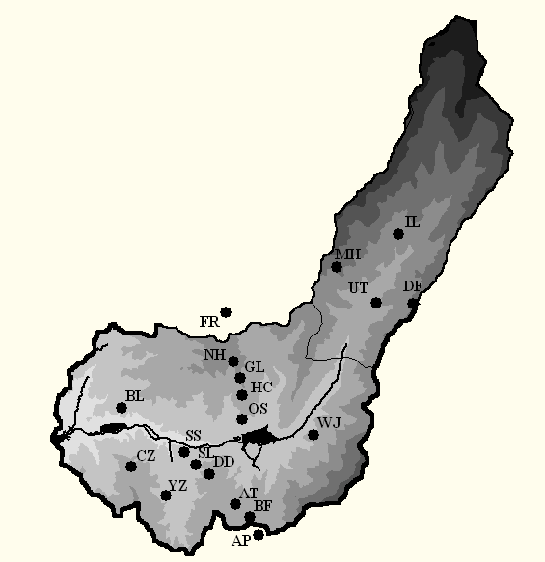

Figure 1: Map of site locations within the Santa Fe Watershed, shaded by elevation (higher elevations receive darker shading). The City of Santa Fe is located to the left of the Watershed’s mouth.

Figure 2: Composite of all verified fire dates from all sites.

Figure 3: Site chronology from site AP. This site is an open ponderosa pine stand on a high ridge just outside the Watershed in the Apache Canyon Headwaters.

Figure 4: Site chronology from site UT. This site is situated just above the Santa Fe River on a north-facing, dense mixed conifer stand. Sample depth is inadequate in this site.

Figure 5: Site chronology from site HC. This site is located halfway between ridge and river on a south-facing ridge.

Figure 6: Site chronology from site NH. This site is located above site HC on the upper part of a south-facing ridge.

Figure 7: Site chronology from site CZ. This site is a young lower Watershed stand suspected to have burned severly in the 1842 fire.

Technical report submitted in partial fulfillment of award #??? from the US Geological Survey

