Sensitivity of Semi-Arid Southwestern Forests to Climate-Induced Disturbances:
Fire History in Northern New Mexico

By

Jeff Balmat, Christopher Baisan,
And
Thomas W. Swetnam

Manuscript

December 16, 2005

FIRE HISTORY OF THE SANTA FÉ MUNICIPAL WATERSHED

INTRODUCTION

Wildfire has assumed a prominent position in land management policy and operations over the past several decades. Recent fires of significant size and economic consequence (e.g., the 2000 Cerro Grande fire at Los Alamos) have given a sharp edge to accumulating ecological research documenting historical fire patterns and human-initiated fire regime change. Wildfire is understood to be a keystone landscape process in most upland and montane forests of the American Southwest (Allen 2002). Over the past century or more in most of this region land use practices have augmented the human dimension of fire occurrence, typically a climate-driven process (Swetnam and Betancourt 1990). Many fire histories reconstructed from dendrochronological evidence show a marked decline or total cessation of fire in the mid 1800s to early 1900s (Swetnam and Baisan 1996), corresponding to the initiation of intensive livestock grazing and fire exclusion policies (Covington and Moore 1994). Responses in forest structure and composition to altered fire regimes often feed back to promote a heightened severity in the fires that do occur. Fire regimes, vegetation patterns and the interactions between the two are expected to be significantly affected by shifts in regional climate.
All southwestern forests are subject to climatic variability and nearly all have felt the effects of land use changes, but the wildland-urban interface is more sensitive and vulnerable in terms of direct human impacts and the potential for resulting changes in wildland fire regimes to dramatically and adversely affect the human and wildland environments. The Santa Fe Municipal Watershed (the Watershed), draining part of the west side of the Sangre de Cristo Mountains in northern New Mexico, is one such location. The 17,384 acre watershed is an important resource to the community of Santa Fe, providing approximately 40% of the municipal water supply (USFS 2001). Most of the Watershed is part of the Espanola Ranger District of the Santa Fe National Forest. The City of Santa Fe and the US Forest Service are charged with the task of managing the water resources of the watershed, which are invariably influenced by ecological processes. Wildfire is of particular concern because of the magnitude and cascading nature of fire effects on forest ecology and hydrology. Wildlife and other valued resources of the Watershed are also affected by fire events.
The objectives of this research were to establish a network of fire chronologies within the Santa Fe Municipal Watershed (Figure 1a), examine the spatial and temporal patterns of historic fire occurrence as recorded in those chronologies, and evaluate the extent to which climate entrained historic fire occurrence.

METHODS

Field Methods
We used a targeted sampling approach to collect fire history samples at eight sites approximately 1 ha in size along an elevation transect on opposing sides of the lower Santa Fe Watershed (Figure 1b). Four plots are located near the apex of a south-facing ridge that ascends from McClure Reservoir to the Watershed boundary at the head of Black Canyon drainage in the adjacent Little Tesuque Watershed. Four plots are located on the north- to northwest-facing ridge that forms the eastern edge of the Agua Sarca drainage, ascending from just downstream of McClure Reservoir to the Watershed boundary at the Apache Canyon headwaters of the Galisteo Watershed.
The transect was extended into the two adjacent watersheds, Black Canyon to the north and Apache Canyon to the south, and one site was collected in each of these watersheds. Samples were also taken at additional locations throughout the Watershed but are not quantitatively analyzed here because of low sample depth. These samples may support future environmental history work in this Watershed.
General site and vegetation descriptions were collected to enhance site history interpretation.

Laboratory Methods
Sample preparation followed standard procedures: samples were sanded and crossdated, to the season, if possible (Stokes and Smiley 1968, Baisan and Swetnam 1990). Crossdating was verified using regional reference chronologies (NM I/J; Dean and Robinson 1978). We entered the fire scar data recorded in the samples into the Fire History Database developed by Richmond (2004) then exported to FHX2 format files for graphical and statistical analysis (Grissino-Mayer 2001).

Statistical Analysis of Temporal and Spatial Patterns
Sites were divided into two groups for statistical analysis—warm aspect south-facing sites on the north side of the river and cool aspect north-facing sites located south of the river (Figure 1b). Based on visual interpretation and historical context, we grouped time period of similar fire occurrence and human use history and statistically compared these periods (Baisan and Swetnam 1996). Spatial comparisons between the north- and south-facing plots were accomplished using FHX2 fire history software (Grissino-Mayer 2001).
We calculated measures of central tendency for the unfiltered and filtered (10%, 20%, 25% of recording trees scarred). Assuming that widespread fires scar more trees, such fire event filtering retains only events inferred to be “widespread.” Widespread fires are most crucial to management considerations.
To assess the concurrence of fire across watershed boundaries, we compared fire dates of plots within the watershed and the two aforementioned plots located just south and north of the Watershed.

Climate-Fire Association
Superposed epoch analysis using the EVENT program (Holmes and Swetnam 1994) determined the correlation between interannual variability in available moisture and fire occurrence. We used a PDSI reconstruction (point 133) from the North American Drought Atlas (Cook et al. 1999, 2004) and 10% filter fire years for this analysis.

RESULTS and DISCUSSION

The trees sampled across the McClure Reservoir transect provided information that spanned the last seven centuries (1296 is the earliest sampled inner date, and older remnants undoubtedly exist; Figure 2 shows fire history from 1500 to the present). The period of analysis 1600 to 2004, chosen based on the number of samples available and recording fires, was completely within the period of historical Spanish and American influence in northern New Mexico. Fire chronologies since 1500 are presented in Figure 1a and 1b; results of mean fire interval analysis are presented in Table 1a and 1b. Fires occurred frequently during the 1600s, particularly on south-facing sites, until about 1670 when the interval between fires lengthened. Fire frequency further decreased after 1750. Following a widespread fire in 1842, fires became uncommon in the watershed. The last fire recorded by the sampled trees burned in 1904.

Temporal and Spatial Patterns
The pattern of fire occurrence in the Watershed changes considerably through time. The 1600s are a time of frequent fires (short interval between fires). During the late 1600s, frequency drops off and longer intervals persist for nearly two centuries (Figure 2). The 1842 fire (Figure 3) is the last widespread fire recorded by the sampled trees; the last 160 years have been relatively fire-free. That is not to say that no fires were ignited in the watershed. There is of evidence that smaller fires continued to occur from 1842 to the present, but there have not been any widespread fires that were recorded along the transect plots. For example, site CZ (not along the transect; located just south of the Nichols Reservoir Dam) recorded fires in 1883, 1931, and 1966 (two or more trees recording).
Dividing the period of analysis around the 1680 Pueblo Revolt, we find that the mean fire intervals are significantly longer from 1680 to 1849 (15.7 years) than pre-1680 (6.4 years; 10% scarred, 2 sample minimum; t₁₈ = -4.1031; p = 0.0007) though the variance in the interval distributions were statistically indistinguishable (folded F_{9,9} = 1.3430; p = 0.688) (Table 1).
The mean fire intervals of the south-facing (11.5 years) and north-facing (15.0 years) sides of the Watershed, though different, are not statistically so (t₃₄ = -1.0353, p = 0.3047; 1600-2004, 2 sample minimum) (Table 1). Though fire number was too low to statistically compare higher and lower elevation sites, visual inspection did not reveal any identifiable patterns.
“Patchy” smaller fires were common throughout the record and typical examples are the fires of 1606 and 1686 (Figure 4a and 4b). In addition to such smaller fires widespread fires were also common. Thirteen fires exceeded the 25% samples scarred threshold in the post-1600 period and four of these scarred more than 50% of the samples collected. Figures 4c and 4d depict examples of such events.

Fire Season Analysis
Fire scar position within each growth ring was complied and analyzed and the results are presented in Figure 5. Dormant and early season scars dominated throughout the reconstructed fire record suggesting most fire activity occurred in May or early June, typical for this region. A few late season scars noted during the 19th century could indicate cultural influence, perhaps burning by herders or woodsmen in August or September.

Climate-Fire Relations Using Superposed Epoch Analysis
Climate analysis also reveals a pattern change centered around 1680. Analyses for the entire period of record (1296-2004) and the period of analysis (1600-2004) both reveal a pattern of wet conditions for three years preceding a fire and drought conditions the year of the fire (Figures 6a and 6b). This pattern has been widely recognized in the southwestern US and is generally ascribed to several wet years resulting in a buildup of fuels and a dampening of fire activity which then ignites and spreads readily during subsequent moderate to severe drought conditions (Swetnam and Baisan 1996). However, fires from 1600-1679 were generally preceded by a moderately wet year and fire years themselves had no significant character. From 1680-2004, fires were preceded by wet conditions occurring two and three years prior to the fire year, and fire years were characterized by generally dry conditions. This change is similar to that noted in Sandia Mountains to the south by Baisan and Swetnam (1996) where lack of a clear climate signal characterized fire occurrence prior to the Pueblo revolt.
While the above statements apply to fires scarring a minimum of 10% of sampled trees, the more widespread fires, those scarring at least 25% of samples or the more restrictive 50%, showed a very strong relationship to climate regardless of time period with wet years preceding a very dry fire year. In fact, the 50% criterion which included only four fire years, still met the significance test at the 99.9% level with an average PDSI value of less than –4 and a lag-year 2 value meeting the 99% test at greater than +3. This shows that climatic antecedents and drought years were tied closely to the occurrence of the largest fires in the watershed without regard to cultural context. Similar climatic conditions occur on average four times per century so about one third of these actually saw a widespread fire occur in the Santa Fe watershed.

Cultural Influences on Fire Regime
The pattern of reduced fire activity beginning in the late 17th century suggested changes in fire regime that might be linked to cultural changes in the vicinity of the watershed (Savage and Swetnam 1990, Touchan and Swetnam 1992, Touchan et. al. 1993, Baisan and Swetnam 1996). For comparative purposes the data was divided into five periods as follows (Table 2). Period I: prior to the Pueblo Revolt of 1680, Period II: post revolt to about 1700 following the return of Spanish colonists to the north, Period III: from about 1700 to the defeat of the Comanches by Governor Juan Bautista de Anza in 1779 and the peace treaty of 1786, Period IV: from the peace treaty to the grazing and fire suppression era at the end of the 19th and beginning of the 20th century, and Period V: fire suppression during the 20th century.
For the transect as a whole as well as for the warm aspect sites there is a clear trend toward longer fire intervals with time that coincides with a general trend of increase in Euro-Spanish influence and associated land-use practices (e.g., livestock grazing) and decreasing influence of the indigenous inhabitants (Charles 1940, Bailey 1980, Touchan et. al. 1993, Baisan and Swetnam 1996). The generally high fire frequency experienced by the warm sites during the first period also reflects similar findings in the region in areas with strong cultural influences (Figure 8). In fact a north-south transect of sites from the Chuska Mountains and Cerro Pedernal in the Jemez to the Oscura Mountains and Salinas Peak south of Socorro shows an interesting set of similar patterns (Figure 9a). Conversely, a set of sites located west of the Rio Grande River and in areas generally remote from settled human influences shows no such trend in fire frequency (Figure 9b). A reasonable explanation for the observed pattern is the reduction in fine fuels associated with livestock grazing that limits fire spread.
The cool aspect sites show a less clear pattern with reduction in fire frequency only in the later period. Fire intervals were longer throughout the record reconstructed from these sites and the link to climate conditions relatively stronger (Figure 10). With conditions favorable for burning occurring less often, perhaps the fuel reduction from grazing had less of an impact on fire in this part of the watershed until the 19th century.

Wood Harvesting

Evidence of wood harvesting for construction timbers and fuelwood was undoubtedly very common. Evidence of cutting was noted throughout the areas sampled and samples were collected from a number of stumps showing evidence of harvest. Cutting dates are shown in Table 3. The dates provide evidence of a long history of cutting and while some areas may have been heavily harvested the areas we sampled had only experienced selective harvest and many old-growth trees remained.

Some Management Implications

Land use practices in the watershed appear to have had an impact throughout the reconstructed record. Proximity to Santa Fe undoubtedly made the resources of forage and timber highly desirable and led to extensive utilization particularly in the lower portions of the watershed (Figure 11). While the exclusion of most uses over the past 60 years has lead to recovery of the vegetation in the lower reaches the practice of fire exclusion has lead to other management problems. The high density of trees that developed created a significant risk of high severity fire occurring and the potential for severe erosion and watershed damage. While the current thinning project has lessened this risk the majority of the watershed remains untreated. This upper portion of the basin is characterized by steep slopes and a dense forested cover of mixed-conifer, spruce and fir. These forest types burn infrequently, but as the reconstructed fire history shows widespread fires occurred in the lower portion of the basin commonly on drought years under extreme conditions that would be conducive to fire spreading into the upper portion of the watershed. The apparently even-aged stands and burned stumps and logs that were noted in the area agree with fire history patterns of collection sites not described here in suggesting that fires did occur in the upper watershed as well. Consideration should be given to the consequences of fires occurring in all portions of the watershed.
Current thinning and fire break operations along the Watershed boundary ridge is intended to decrease the likelihood of fire from adjacent watersheds spilling over the ridge. Historically, there is concurrence between fire years among sites along the boundary. Along the northern boundary, six of the ten fires recorded on the north side (site FR, in the Black Canyon drainage) were also recorded at the highest site inside the Watershed (site NH, inside the Watershed). Along the southern boundary, seven of ten fires recorded on the north side of the boundary (site BF, inside the Watershed) were also recorded just south of the boundary (site AP, in the Apache Canyon drainage). At this location, it is also worth noting site AP is an open, grassy, ponderosa pine forest. Just over the ridge, site BF is a thick mixed conifer stand with standing snags. Both recorded the 1842 fire, but it seems to have burned with different intensities at the adjacent sites.
Fire has clearly played a role in the Santa Fe River watershed over the past 700 years and will surely continue to do so. Land use and management of the area should account for the possibility of fire occurrence. Policies and practices that prepare for and attempt to mitigate the consequences of fire will undoubtedly benefit the community of Santa Fe.

Acknowledgements

Funding for this project was provided by the US Geological Survey under agreement number XXXXXXXX.
Although many people assisted with this project whose help is gratefully remembered, the following individuals deserve special mention: Craig Allen, Devin Petry, Erica Bigio, Greg Pollak, Paige Grant, Janine Johnston, Mike Gonzalez, Sandy Hurlocker, Jamie Brytowski and the students of Santa Fe College, Jake Williams, Kiyomi Morino, Kay Beeley, Rebecca Ortiz, Pepe Iniguez, Ellis Margolis, and Merrick Richmond.
Assistance and logistical support were also provided by the USFS, Española Ranger District, the Santa Fé Watershed Association, the City of Santa Fé Water District, The Nature Conservancy, the Randall-Davey Audubon Center, and Chavez Security, Inc.

References Cited

Allen, C.D. 2002. Lots of lightning and plenty of people: An ecological history of fire in the upland Southwest. p. 143-193. In: T.R. Vale (ed.). Fire, Native Peoples, and the Natural Landscape. Island Press, Covelo, CA. 238 p.

Bailey, L.R. 1980. If you take my sheep. Westernlore Publications, Pasadena, Ca. 300pp

Baisan, C.H. and T.W. Swetnam, 1990. Fire history on a desert mountain range: Rincon Mountain Wilderness, Arizona, U.S.A. Can. J. For. Res.

Baisan, C.H., Swetnam, T.W. 1997. Interactions of fire regimes and land use in the central Rio Grande Valley. USDA Forest Service Research Paper RM 330: 1-20.

Cook, E.R., Meko, D.M., Stahle, D.W., Cleaveland, M.K. 1999. Drought reconstructions for the continental United States. Journal of Climate 12(4): 1145-1162.

Ibid, 2004. North American Summer PDSI Reconstructions. IGBP PAGES/World Data Center for Paleoclimatology Data Contribution Series # 2004-045. NOAA/NGDC Paleoclimatology Program, Boulder CO, USA.

Charles, R. 1940. Development of the partido system in the New Mexico sheep industry. MS Thesis, University of New Mexico.

Covington, W. W., and M. M. Moore. 1994. Southwestern ponderosa pine forest structure: changes since Euro-American settlement. Journal of Forestry 92:3947

Dean, J.S., Robinson, W.J. 1978. Expanded tree-ring chronologies for the southwestern United States. Laboratory of Tree-Ring Research, University of Arizona, Tucson, AZ. Chronology Series III, 58 pp.

Grissino-Mayer, H.D. 2001. FHX2 - Software for analyzing temporal and spatial patterns in fire regimes from tree rings. Tree-Ring Research 57(1): 115-124.

Holmes, R. L. and Swetnam, T. W. Program Event Users Manual: Superposed Epoch Analysis in Fire History Studies. Dendroecology Program Library, Laboratory of Tree-Ring Research, University of Arizona. 1994 May: 7 pgs.

Richmond, M. 2004. A database program for entering and analyzing fire history data. Laboratory of Tree-Ring Research, University of Arizona, Tucson. 85721.

Santa Fe National Forest. 2001. Santa Fe Municipal Watershed Project Draft
Environmental Impact Statement. Santa Fe National Forest, 1474 Rodeo Road,
Santa Fe, NM 87504.

Savage, M., Swetnam, T.W. 1990. Early 19th-century fire decline following sheep pasturing in a Navajo ponderosa pine forest. Ecology 71(6): 2374-2378.

Stokes, M.A. and T.L. Smiley. 1968. An Introduction to Tree-Ring Dating. University of Chicago Press.

Swetnam, T.W., Betancourt, J.L. 1990. Fire-Southern Oscillation relations in the southwestern United States. Science 249: 1017-1020.

Swetnam, T.W., Baisan, C.H. 1996. Historical fire regime patterns in the Southwestern United States since AD 1700. In: C.D. Allen, ed., Fire Effects in Southwestern Forests: Proceedings of the Second La Mesa Fire Symposium. USDA Forest Service General Technical Report RM- 286: 11-32.

Touchan, R. and Swetnam, T. W. Fire history of the Jemez Mountains: fire scar chronologies from five locations. final report submitted to the USDA Forest Service, Santa Fe National Forest. USDI Park Service, Bandelier National Monument. 1992: 55p.

Touchan, R.T., T.W. Swetnam, and H.D. Grissino-Mayer. Effects of livestock grazing on pre-settlement fire regimes in New Mexico. In: J. Brown, tech. coord. Proceedings of the Symposium on Fire in Wilderness and Park Management: Past Lessons and Future Opportunities, Missoula, Montana, March 30 to April 1st, 1993. USDA Forest Service Gen. Tech. Rpt., INT.

Table 1a & b: Fire interval analysis statistics for pre- and post-1850 (two sample minimum with varying filters)

Table 2: Historical periods and their respective fire intervals

 | P I (1600-1680) |  | P III (1700-1786) |  | P IV (1786-1904)
 | All fires | 10% | All fires | 10% | All fires | 10%
Transect | 3.6 | 5.8 | 5.4 | 14.3 | 14 | 18.7
Warm sites | 4.6 | 4.9 | 9.4 | 13.2 | 14 | (3 fires)
Cool sites | 8.5 | 10 | 6.7 | 10.1 | 9.8 | 30

Table 3: Harvest dates from collected samples with pre-1900 cutting dates

Sample ID | Sample type | Outer date
AT-4 | Axe-cut stump | Not dated
BL-5 | Axe-cut stump | Not dated
DF-3 | Cut stump | +/- 1839 (weathered)
FR-2 | Cut stump | 1886++ (rotted)
OS-1 | Axe-cut stump | 1856
OS-3 | Cut stump | 1794
SL-4 | Cut stump | 1862
SS-4 | Cut stump | 1862
WJ-4 | Cut stump | Not dated

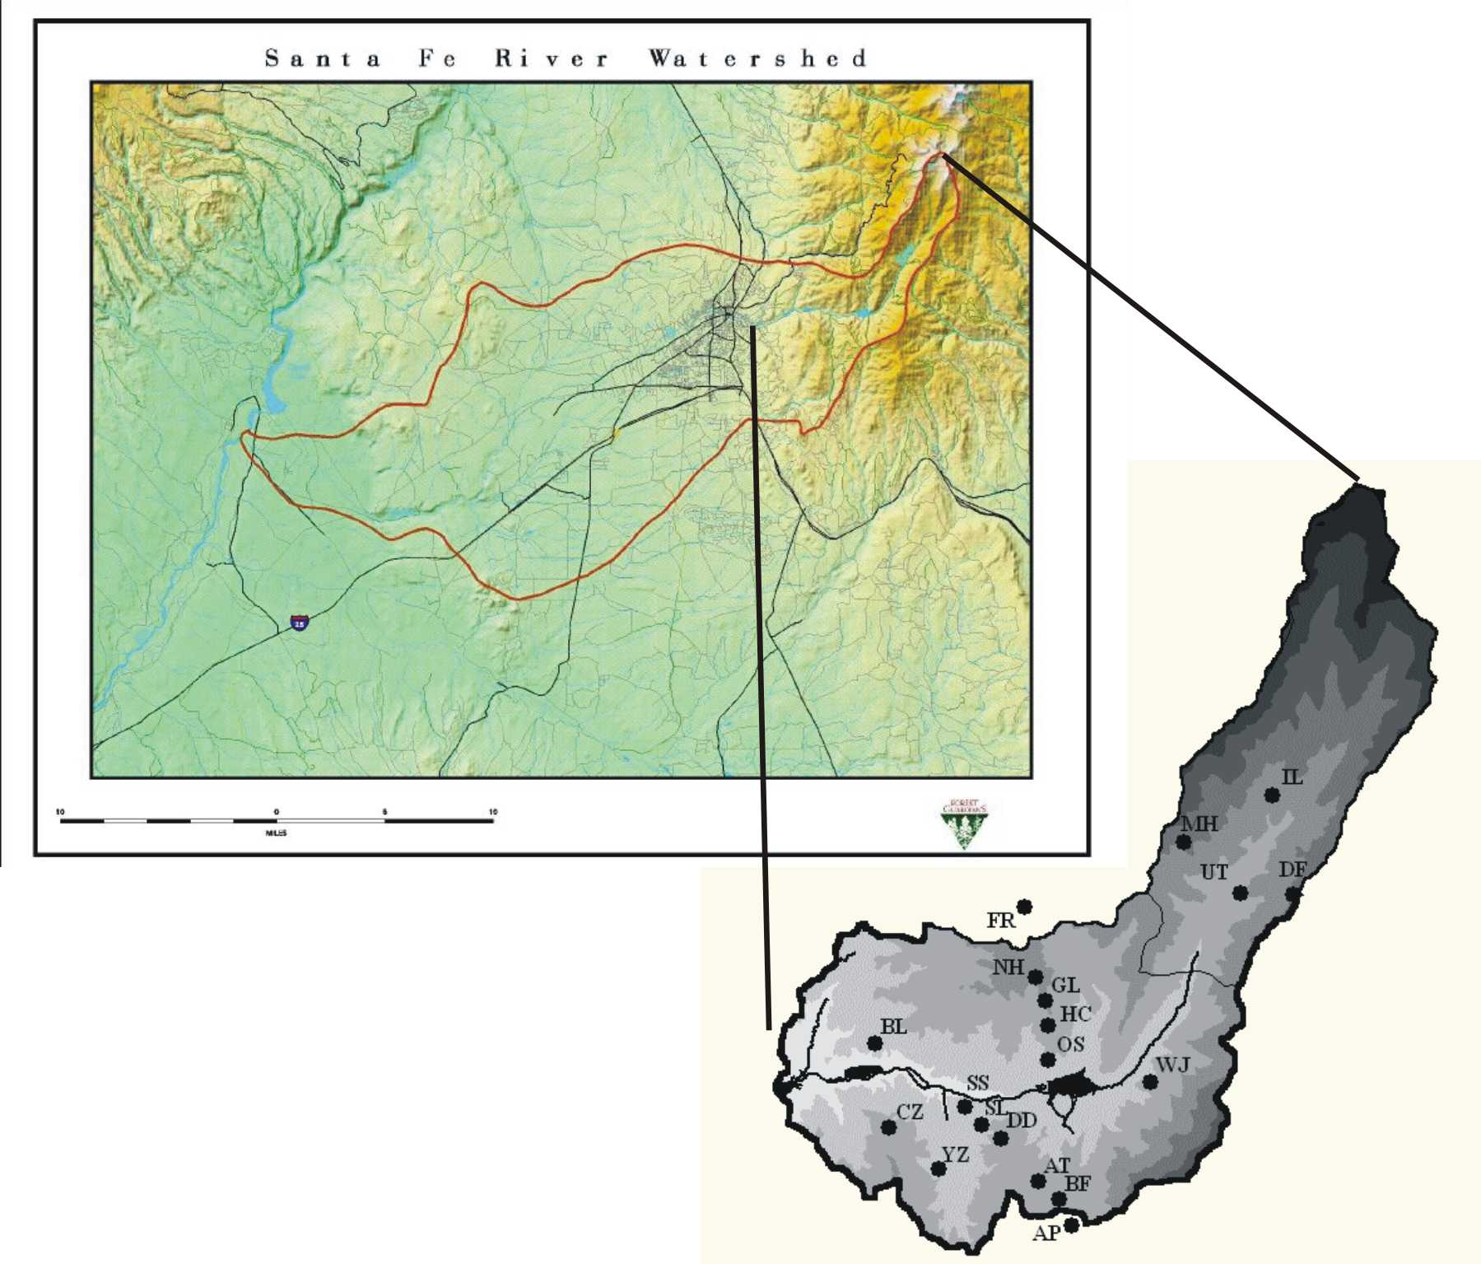

Figure 1a: Map of site locations within the Santa Fe Watershed, shaded by elevation (higher elevations receive darker shading). The City of Santa Fe is located to the left of the Watershed’s mouth.

Can’t use this Forest Guardians map in publication

Figure 1b: Map of transect sites within the Santa Fe Watershed

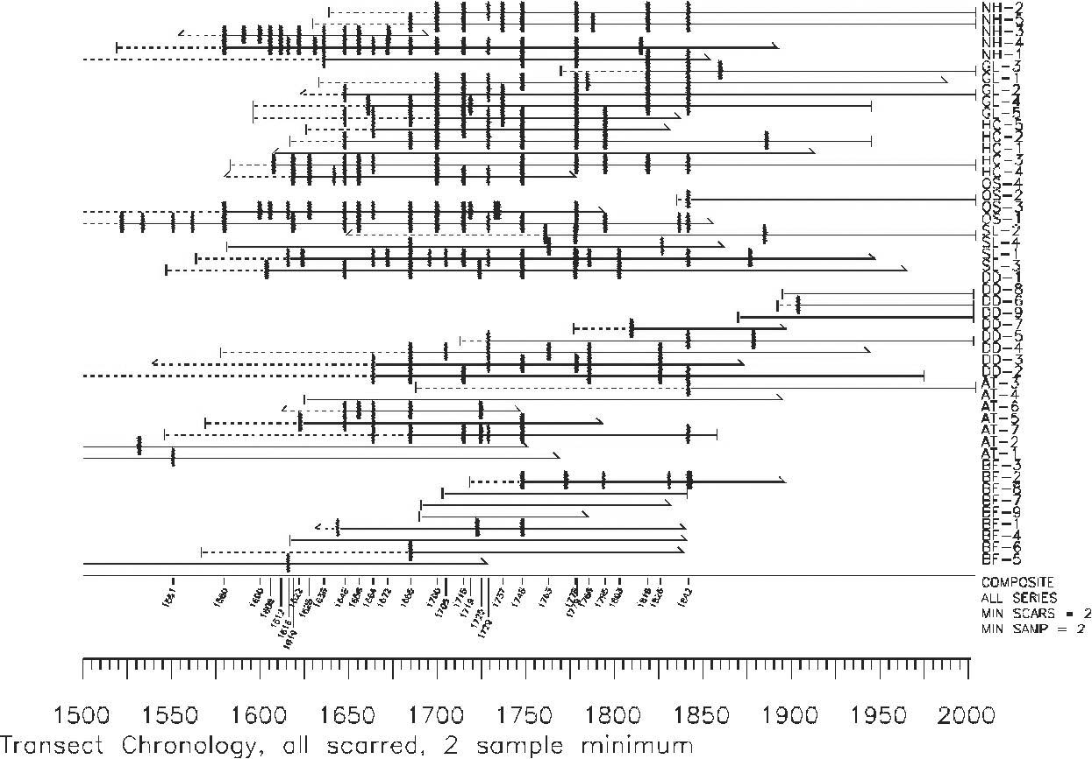

Figure 2a: Chronology of the eight transect plots in geographic order from north to south; the first four plots descend in elevation from the Watershed boundary to McClure Reservoir, the last four plots ascend the Watershed’s north-facing south side.

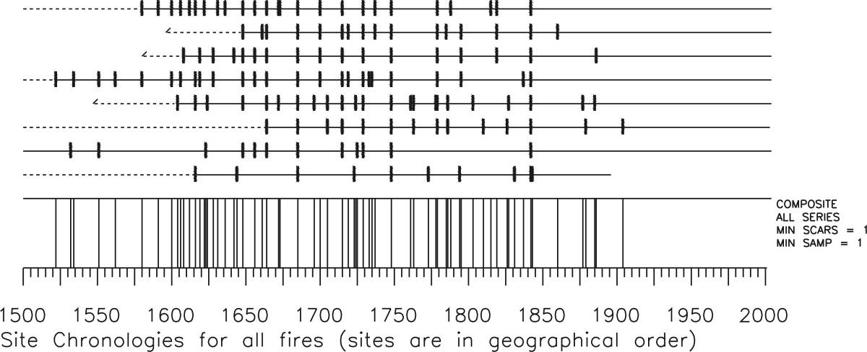

Figure 2b: Site chronologies from each of the 8 transect sites, in geographic order from north to south.

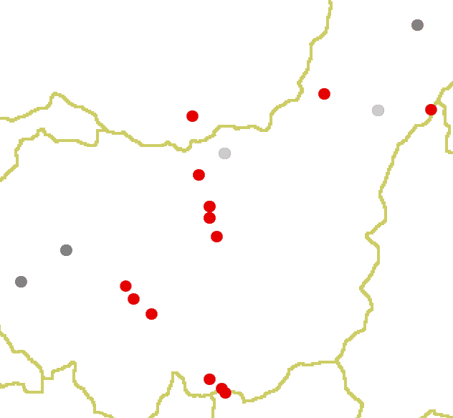

Figure 3: Fire of 1842. Sites with trees scarred in 1842 represented with red dots documenting this relatively widespread event within the watershed. 1842 is a regional drought year and a common fire year in Northern New Mexico. Sites with recording trees but lacking scars for this date in dark grey and those without recording trees in light grey.

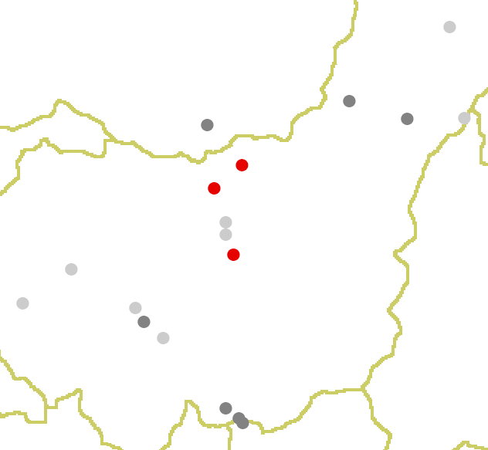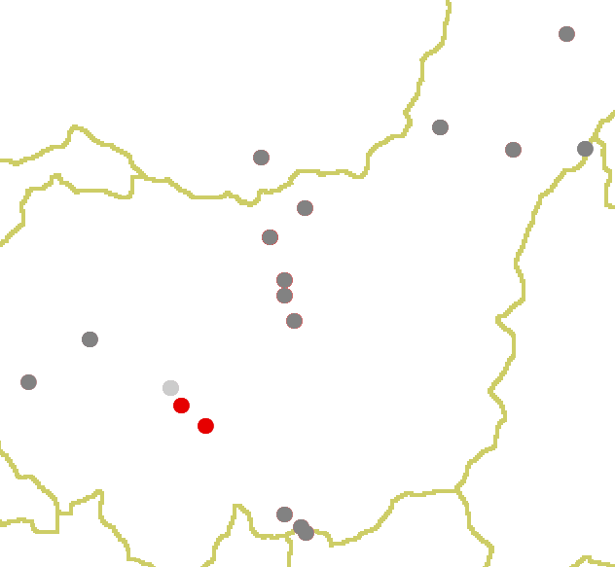

Figure 4a: Fire date 1606 Figure 4b: Fire date 1786

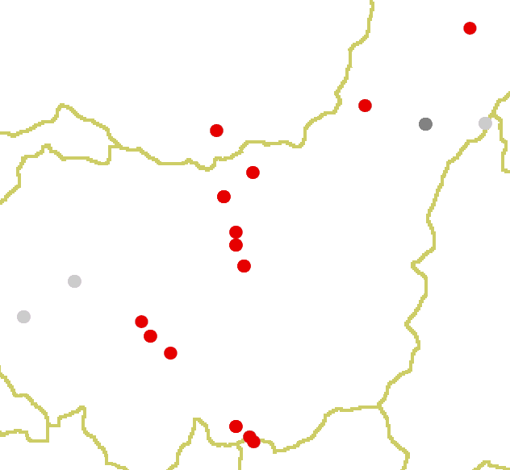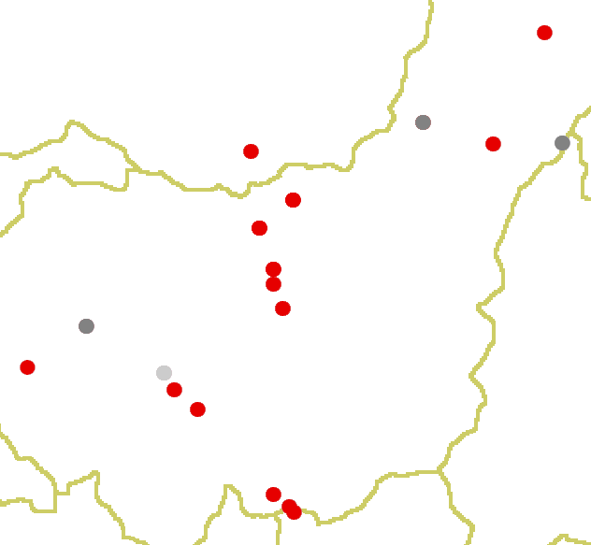

Figure 4c: Fire date 1685 Figure 4d: Fire date 1748

Maps show the occurrence of small or patchy and wide-spread fires for four fire years.

Figure 5: Fire Seasonality Distribution by Century

Figure 6a: Superposed epoch analysis, 1296-2004, 10% scarred, 2 sample minimum (n=26)

Figure 6b: Superposed epoch analysis, 1600-2004, 10% scarred, 2 sample minimum (n=22)

Figure 6c: Superposed epoch analysis, 1600-1679, 10% scarred, 2 sample minimum (n=10)

Figure 6d: Superposed epoch analysis, 1680-1849, 10% scarred, 2 sample minimum (n=11)

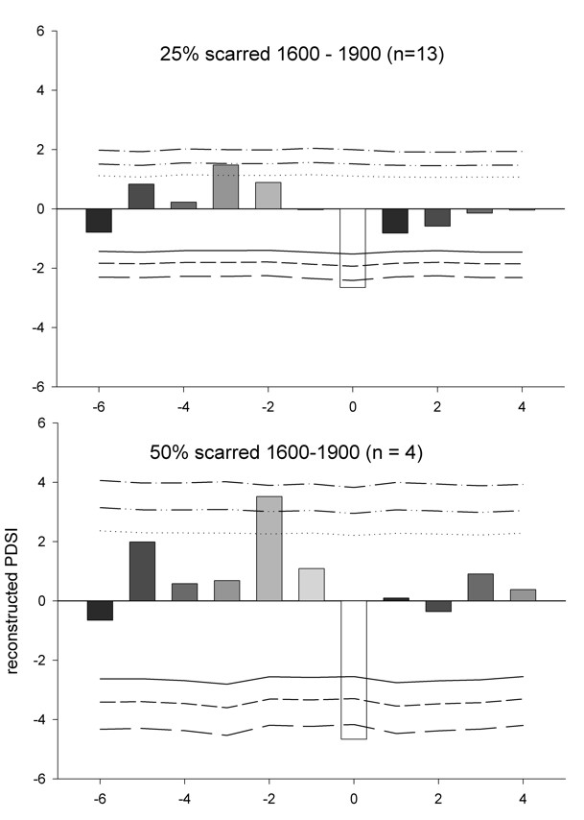

Figure 7a and b: Superposed epoch analysis from Baisan and Swetnam (1996)

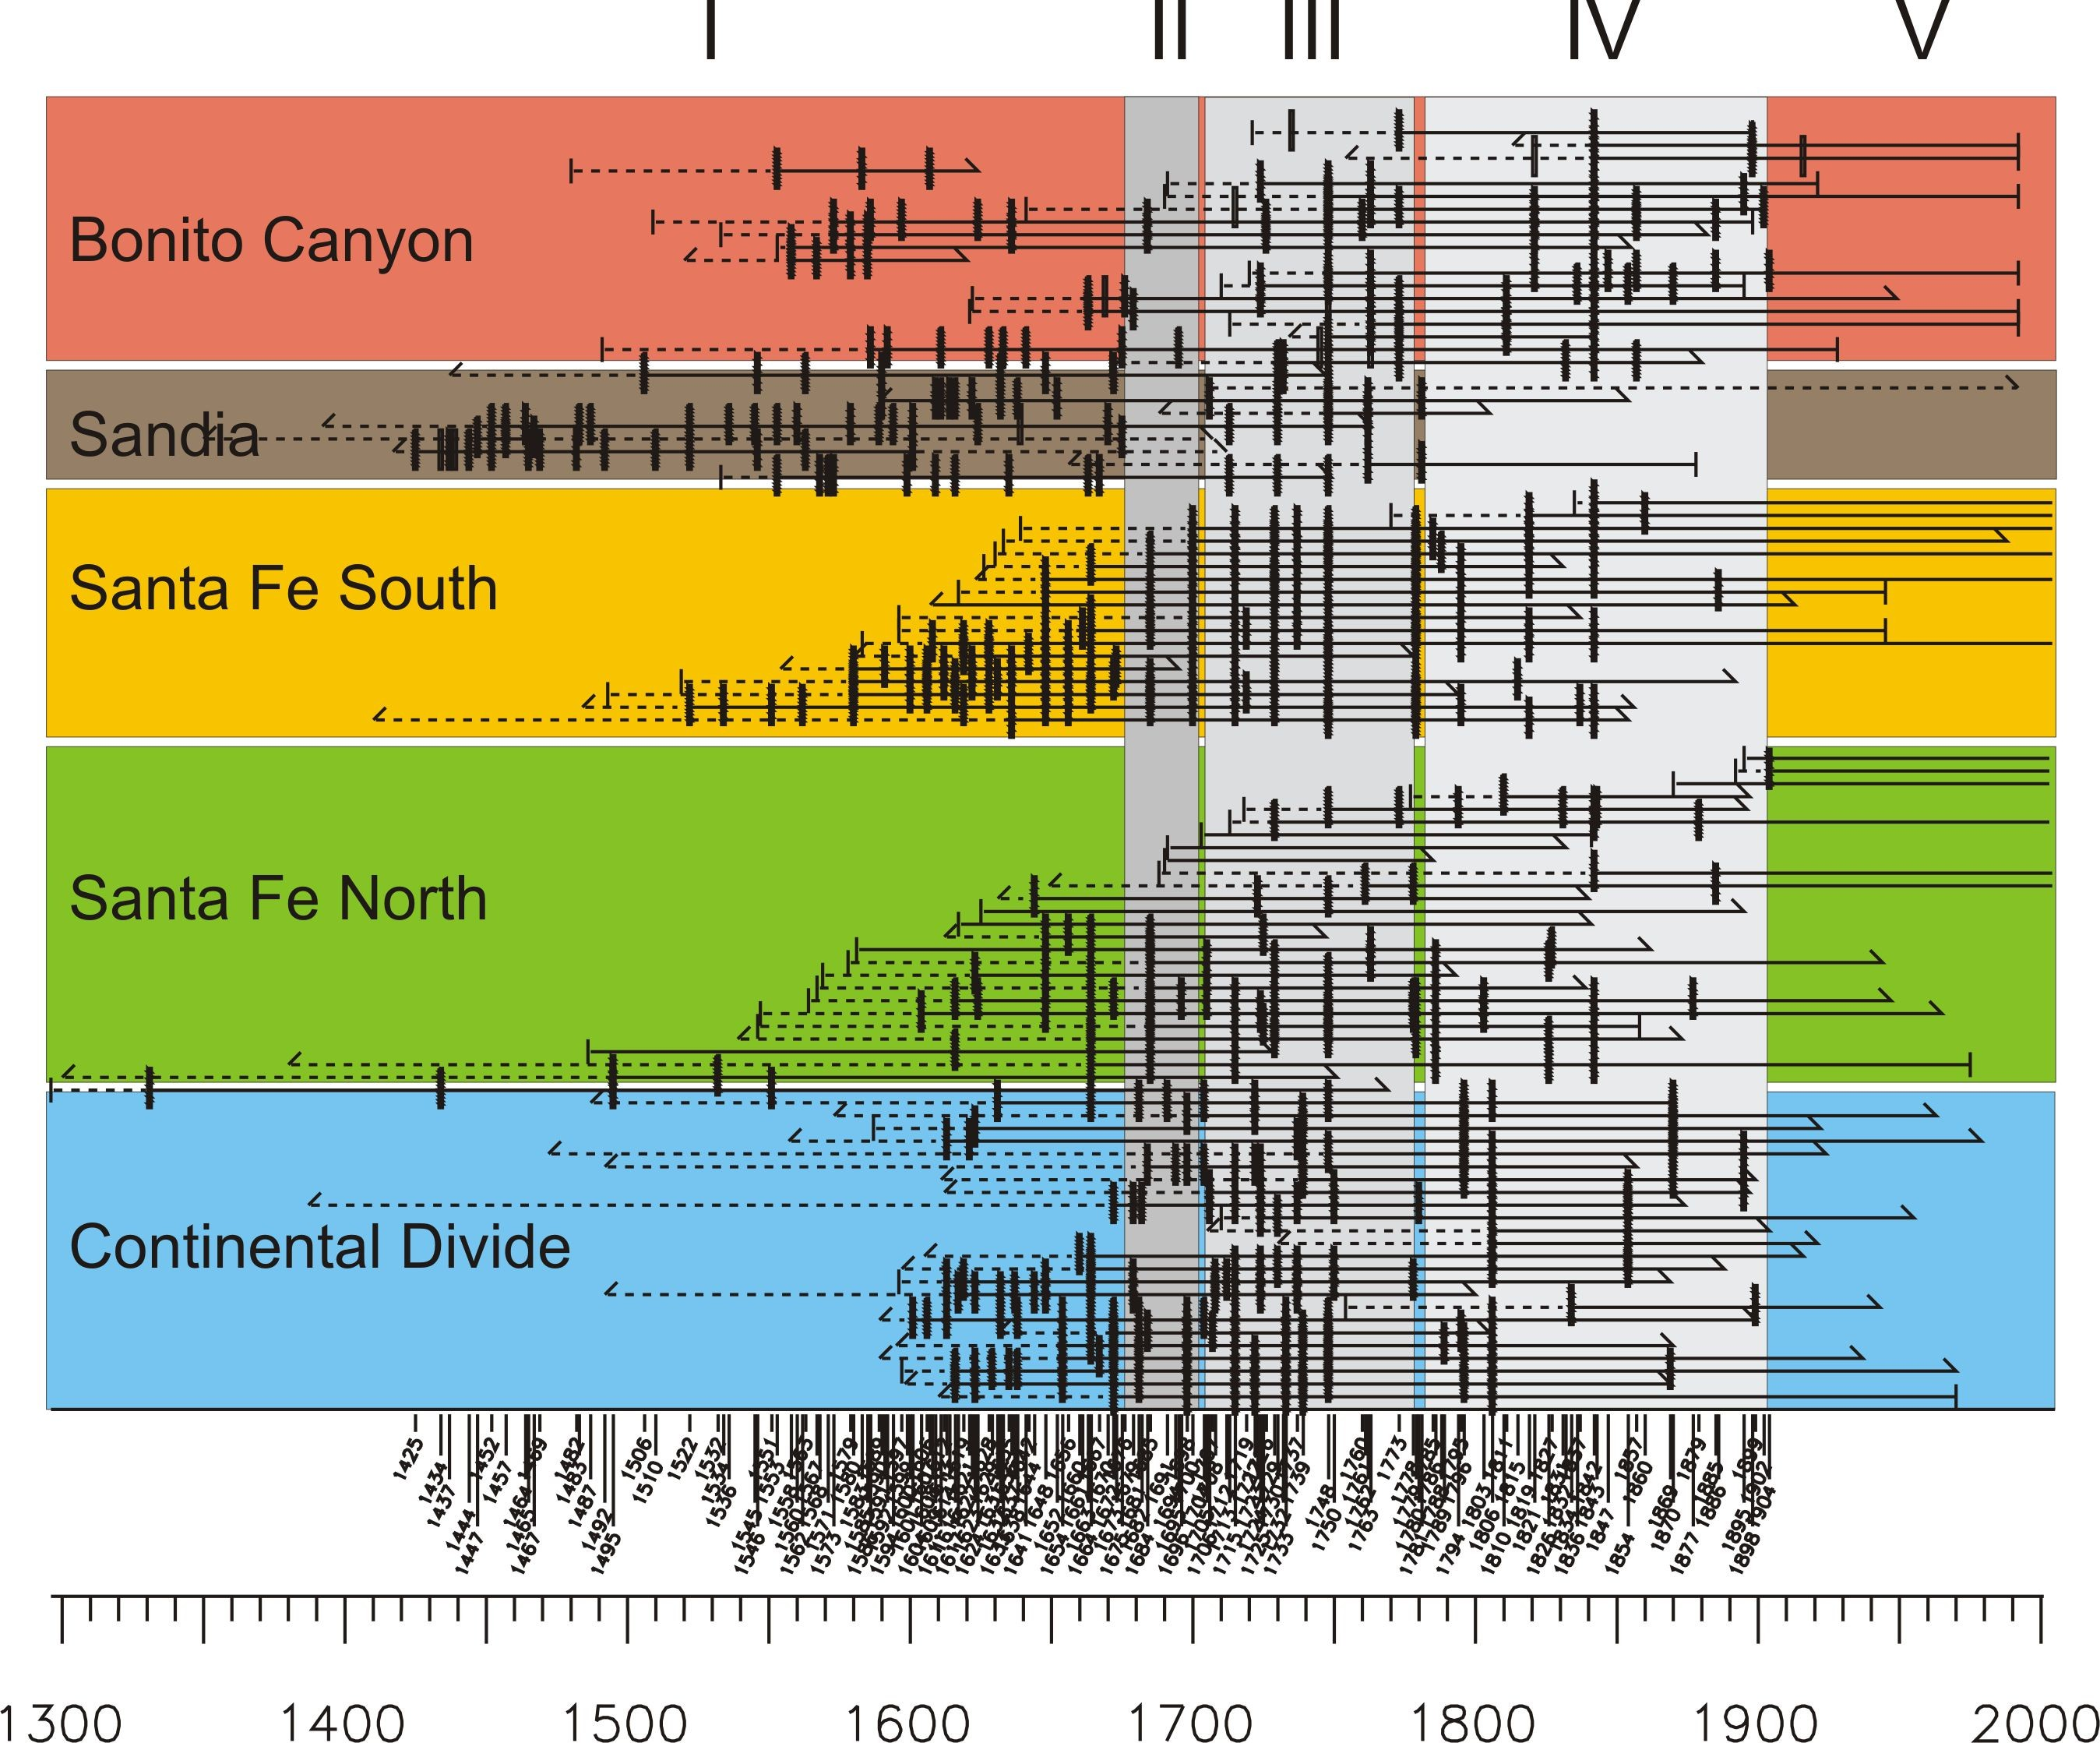

Figure 8: Fire chronology from Baisan and Swetnam (1996)

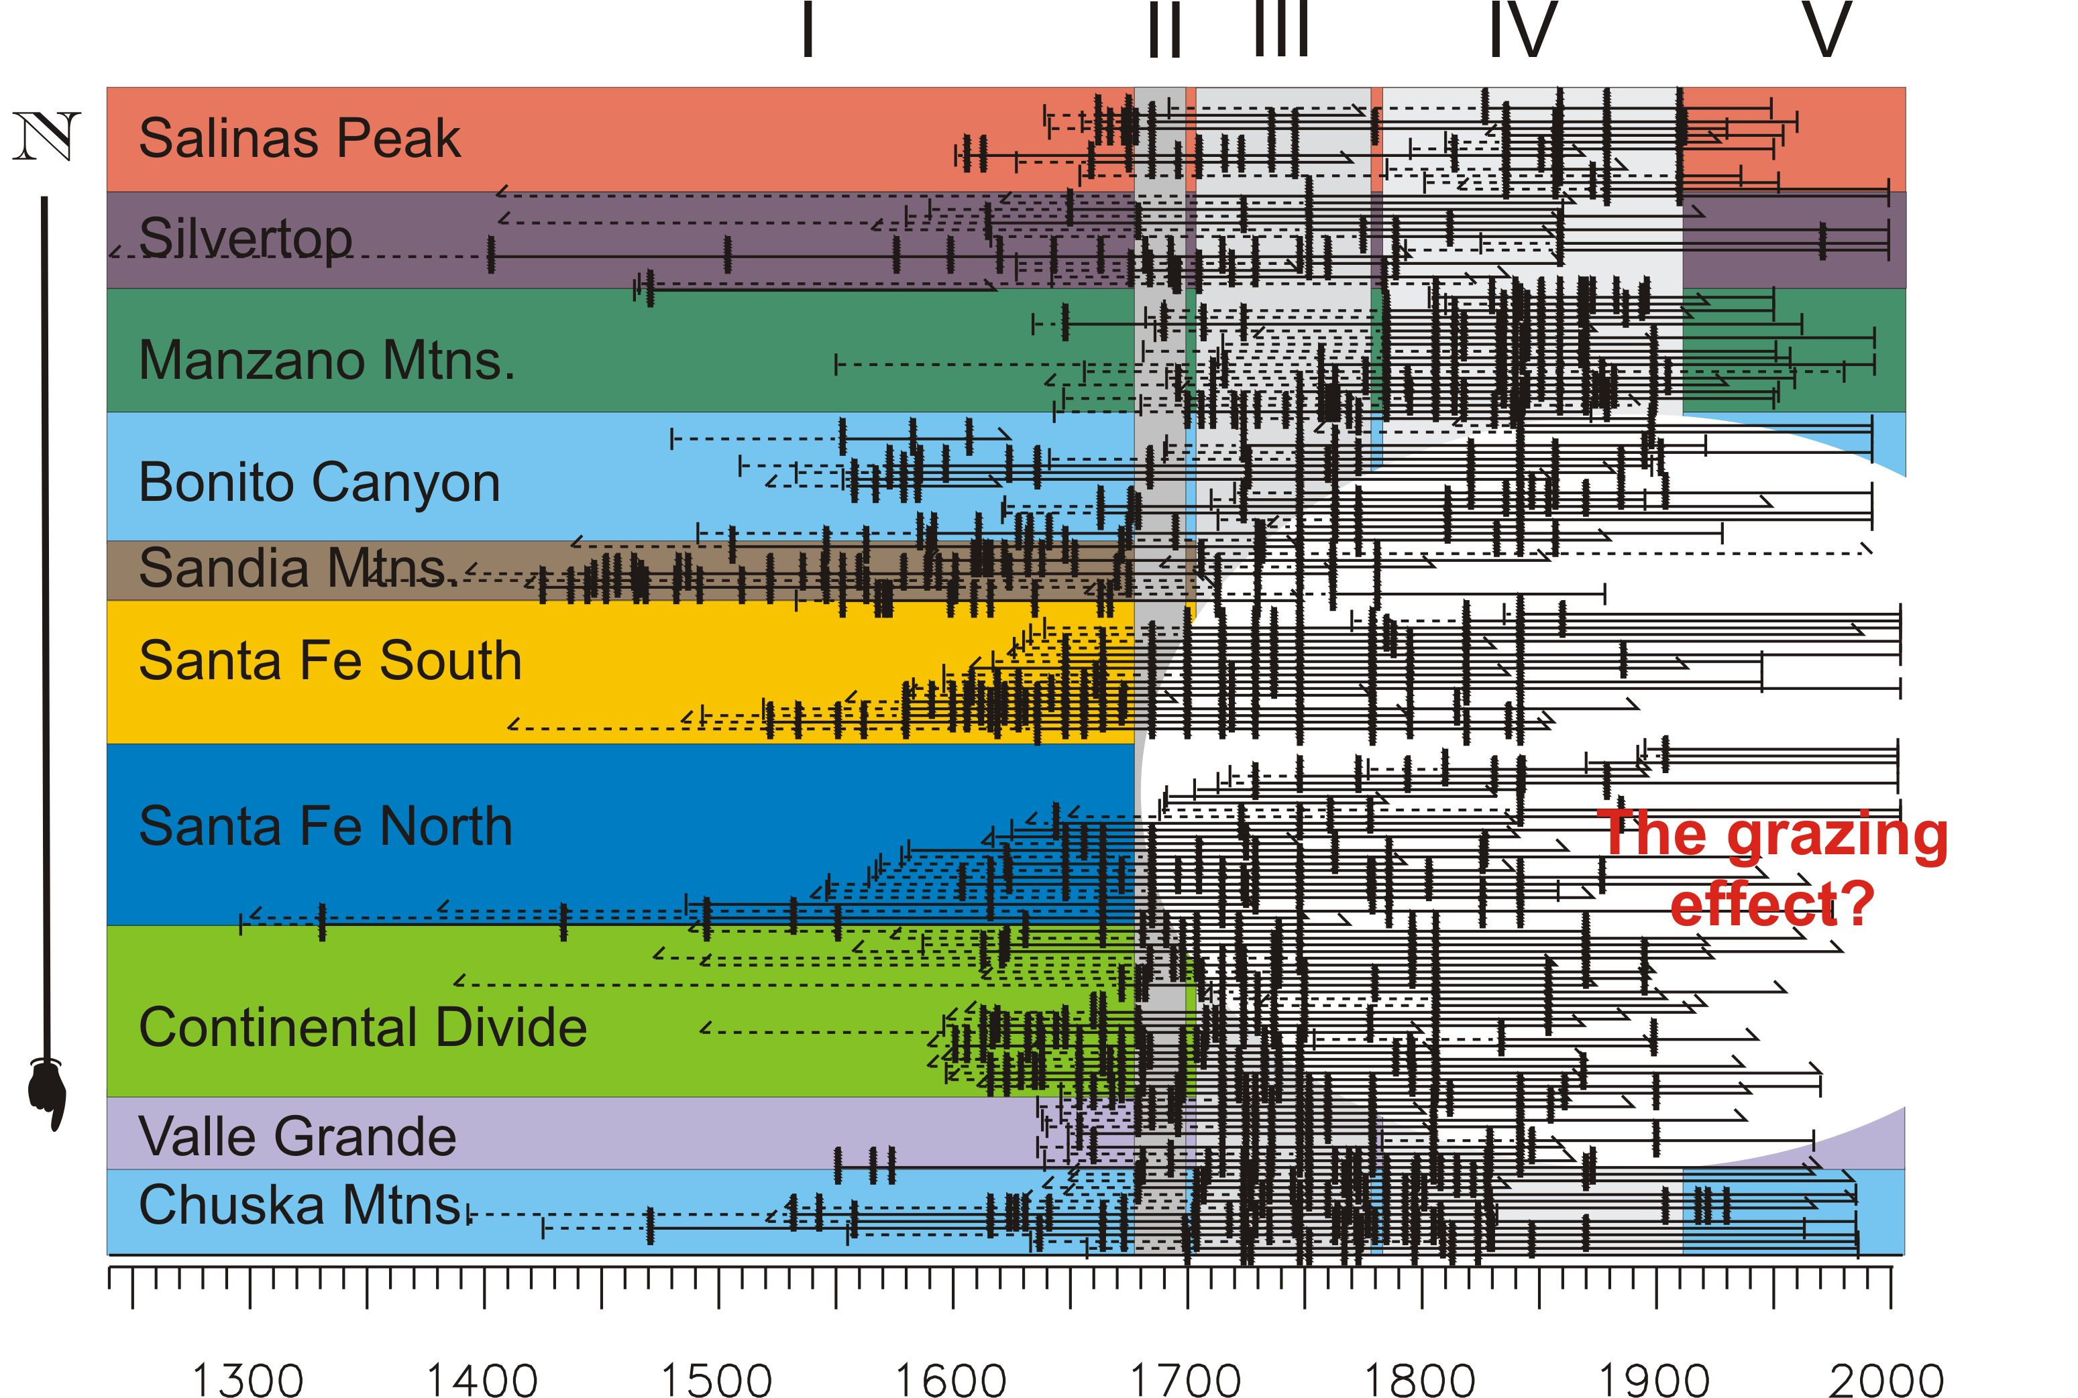

Figure 9a: Fire chronology from Baisan and Swetnam (1996)

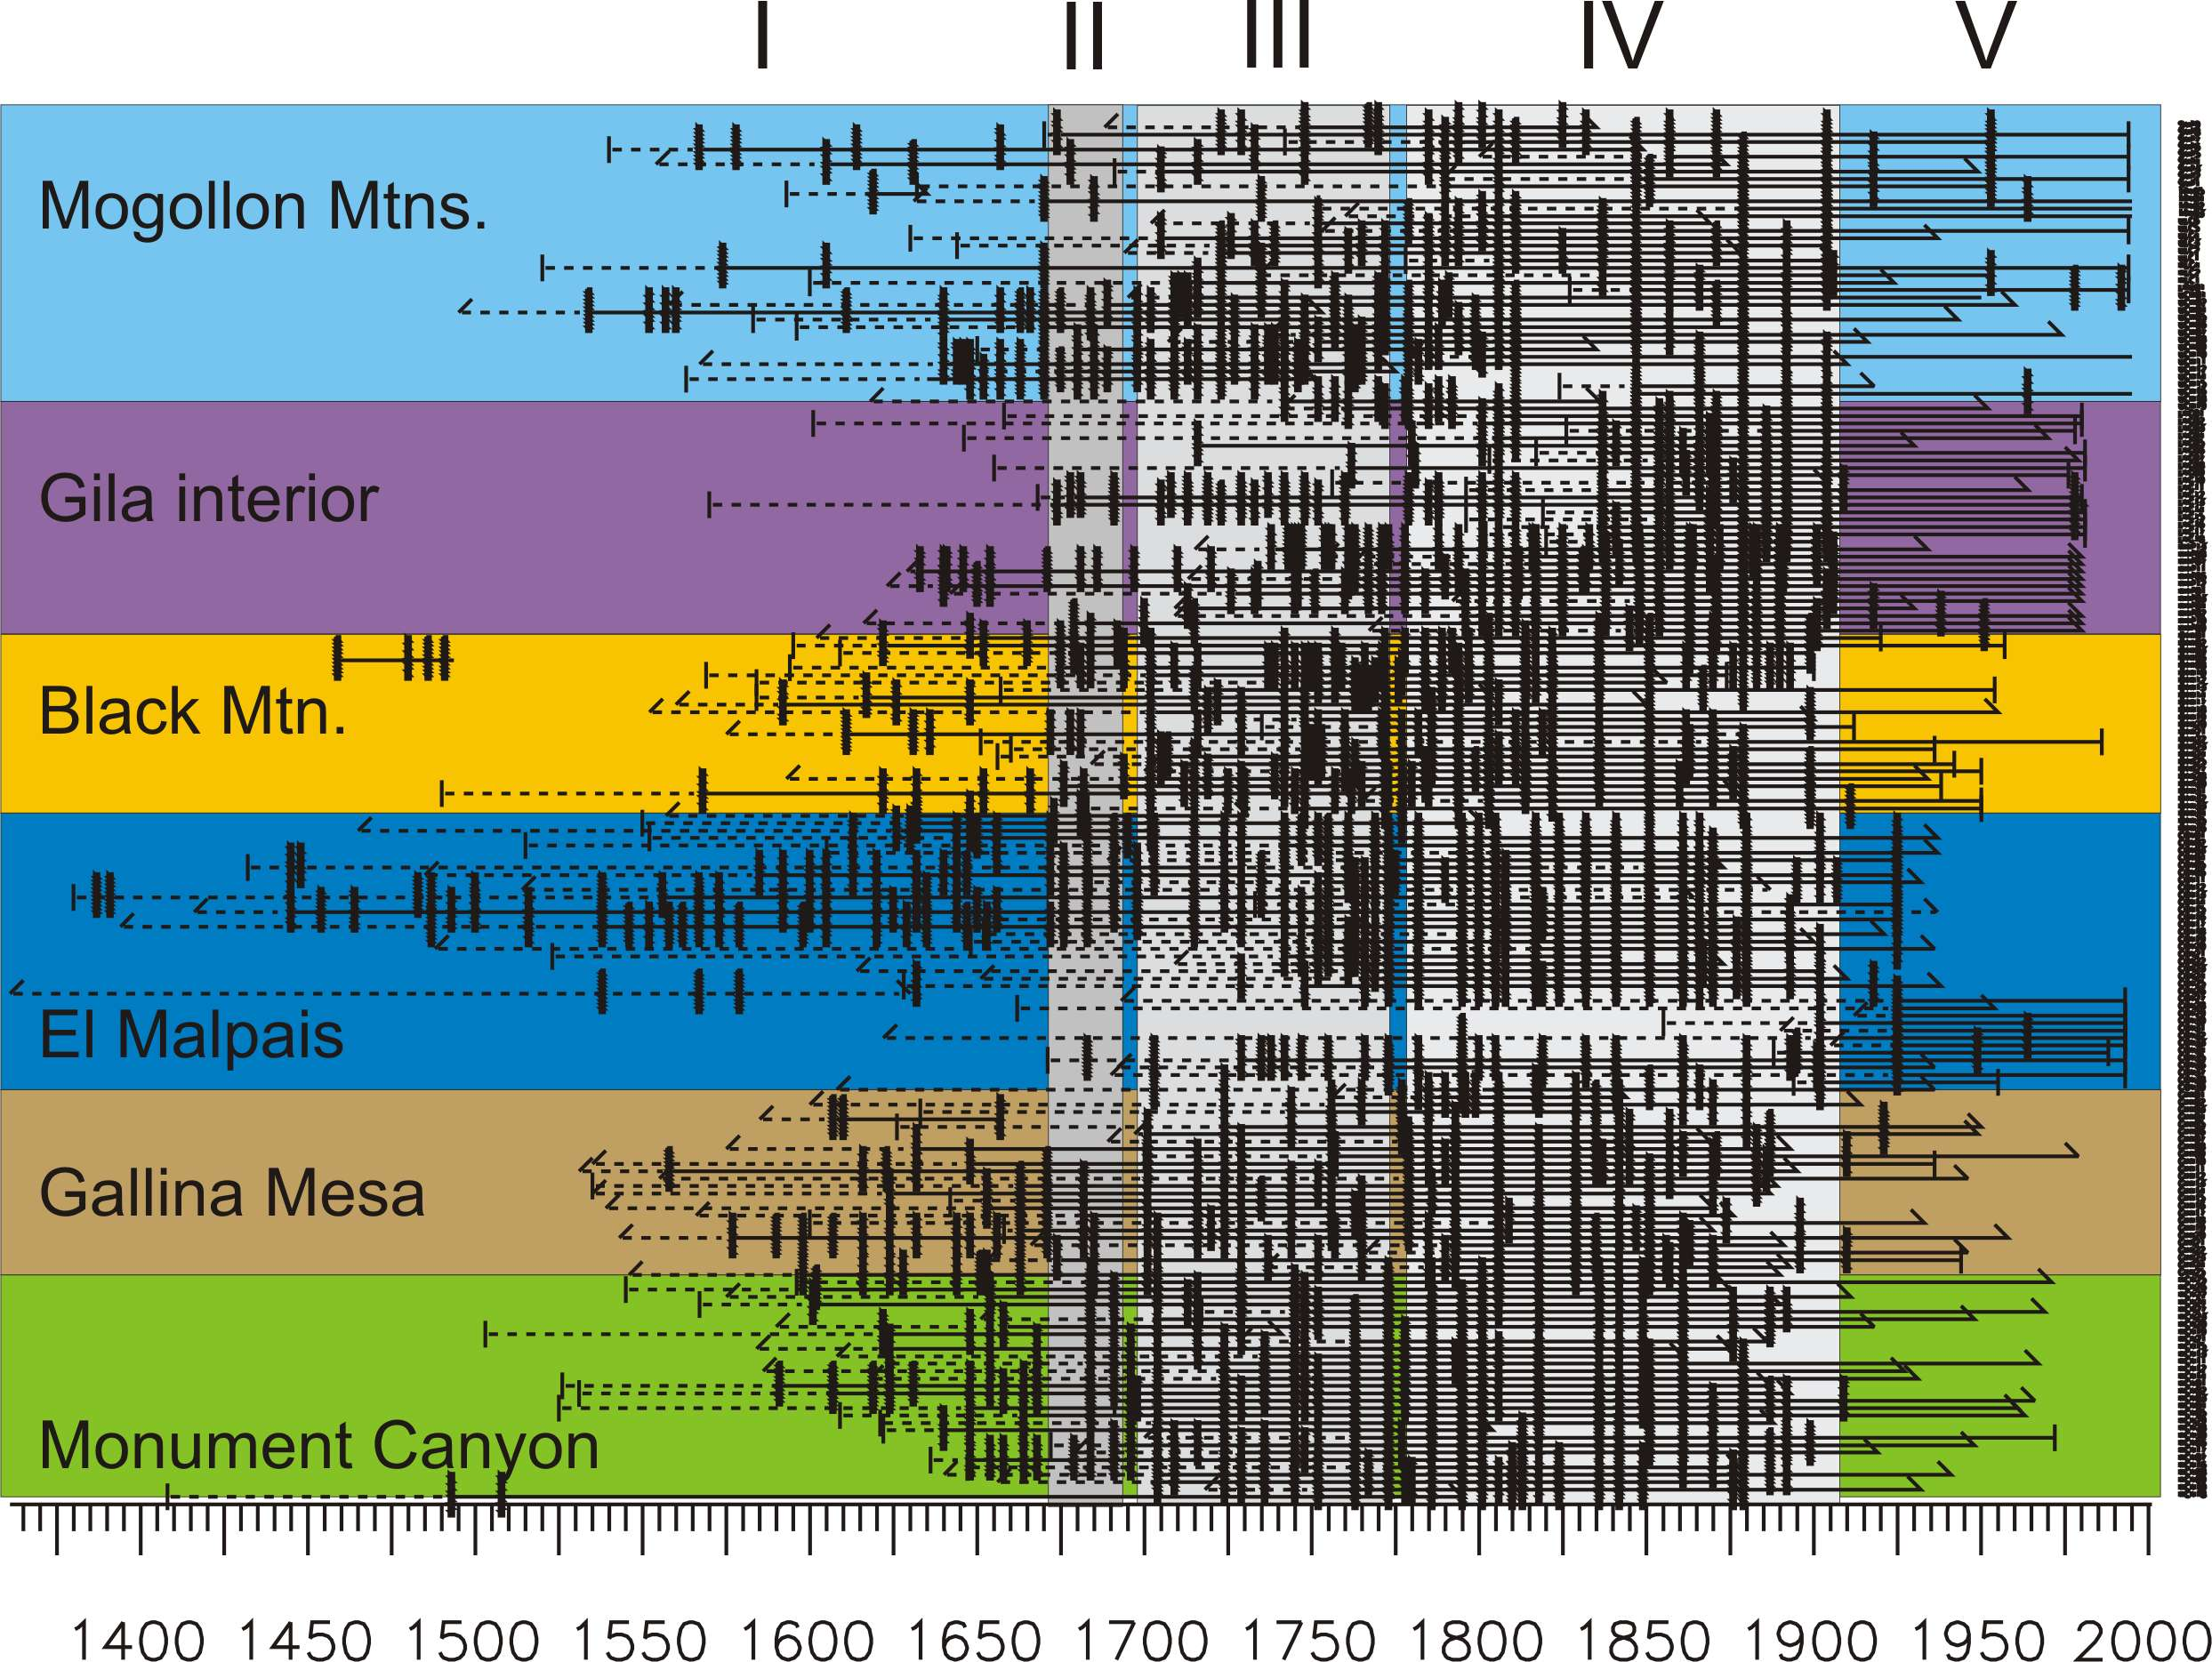

Figure 9b: Fire chronology from Baisan and Swetnam (1996)

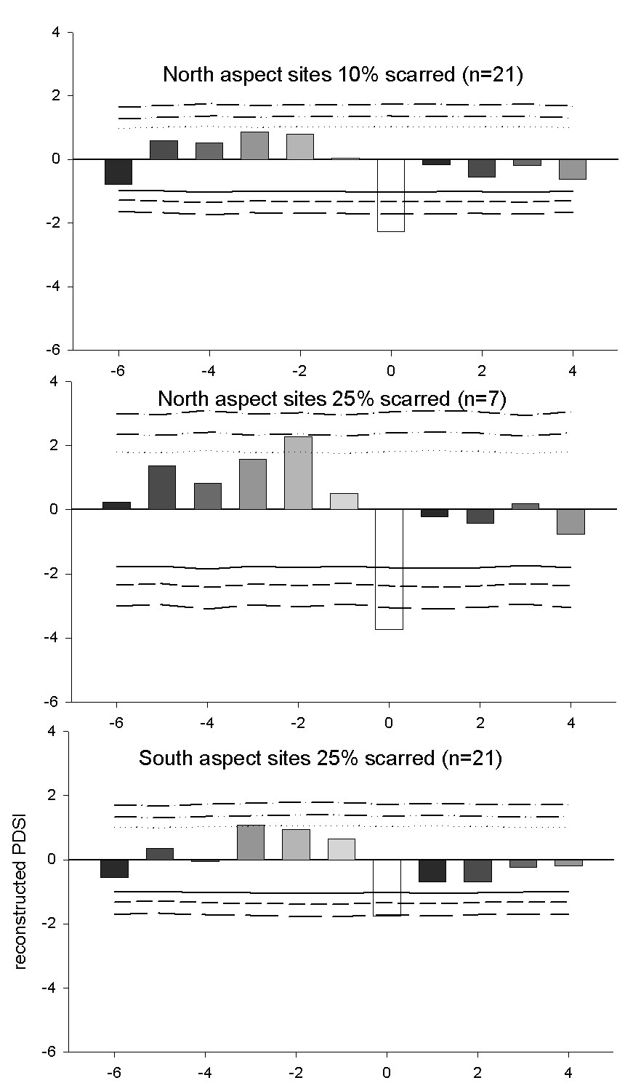

Figure 10: Superposed epoch analysis from Baisan and Swetnam (1996)

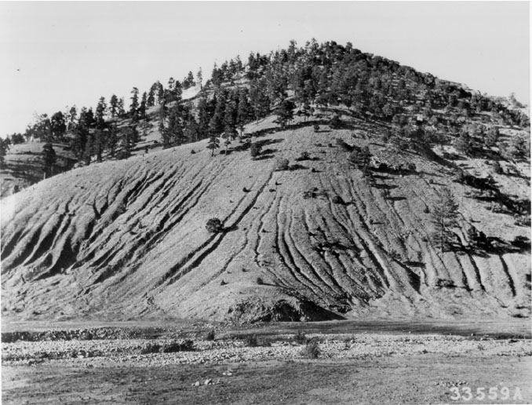

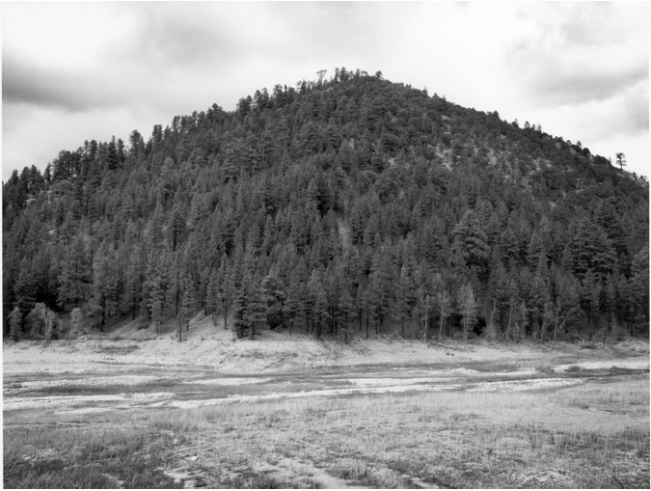

Figure 11a and b. Repeat photographs from 1916 and 2000 showing changes in watershed condition. Extensive grazing, fuelwood and timber cutting had resulted in erosion and watershed degredation.

